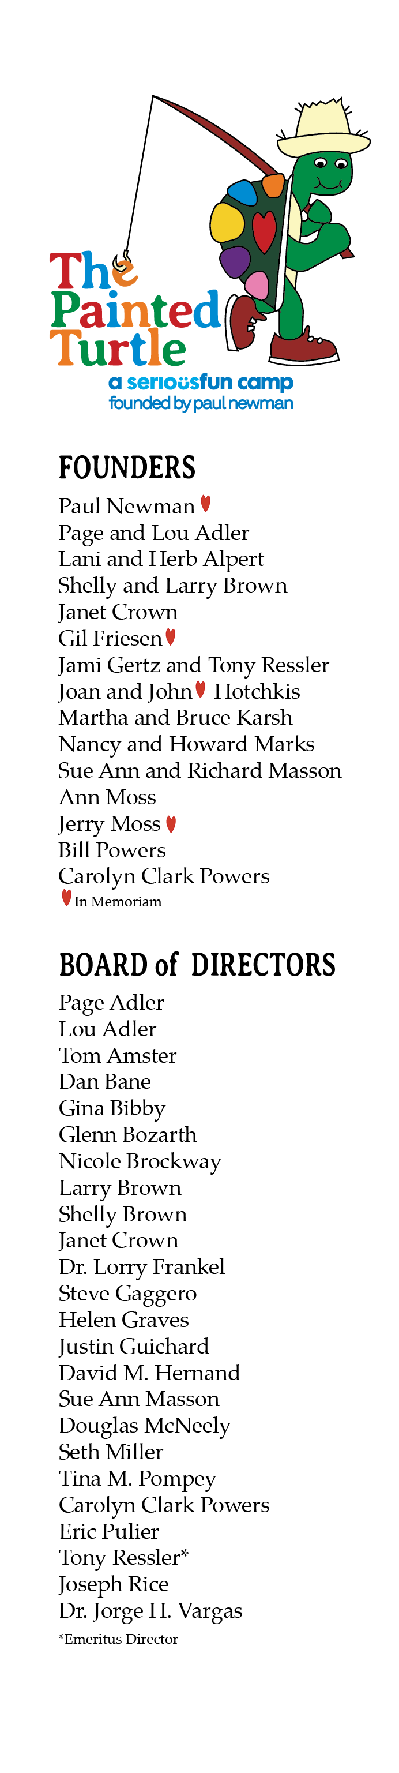

 Dear [First Name],

I believe you know that I am involved with The Painted Turtle, a 501c3 non-profit organization that provides a year-round, life-changing environment and authentic camp experience for children living with chronic and life-threatening illnesses----always free of charge!

This year, The Painted Turtle is celebrating its 20th anniversary and 200,000+ camper experiences since first opening our gates in 2004. Will you donate today to support this incredible mission?

[Personal anecdote about why TPT is meaningful to you or about your experience at TPT]

You can support The Painted Turtle’s 20th Anniversary through December 31st, and help ensure Camp remains 100% FREE for children with serious medical conditions and their families. Donate online through their [**website**](https://www.thepaintedturtle.org/post/give-life-changing-gift-camp) or on the [**20th Anniversary Fundraising page**](https://www.justgiving.com/campaign/celebrating-20-years-200k-camper-experiences).

If you’d like to send a check, it can be made payable to The Painted Turtle

and sent to:

The Painted Turtle

1300 4th Street, Suite #300

Santa Monica, CA 90401

On behalf of the campers, staff, volunteers and everyone involved in The Painted Turtle, thank you for your support and for bringing Camp Magic to life.

With warmest wishes for a joyful Holiday Season,

[Your Name]