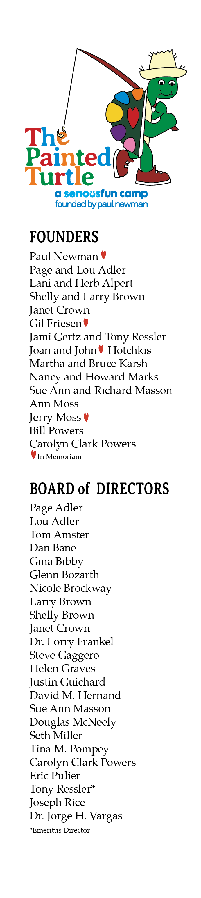

"Share” The Painted Turtle’s post from 12/17 to your story or feed!

Step by Step Instructions for Sharing an Instagram Post
- Visit @thepaintedturtle
- Click on our most recent post (the post reads “Celebrating 20 Years and 200,000 Camper Experiences!” (https://www.instagram.com/p/DDr-Otdyc3O/?igsh=bDZ1dXM0MGllbW5t)
- Click the icon that looks like a paper airplane ➢
- Select “Add to Story” and use the copy below or create your own

Not sure what to say? Use the below content as-is or adjust to your liking:

- The Painted Turtle community is coming together to celebrate an extraordinary 20 years since first opening our gates! Join in on the fun by donating today through December 31st and honor the more than 200,000 campers who have experienced the magic of Camp since 2004 <3 [turtle emoji]. Your donation ensures Camp remains free of charge for children living with serious medical conditions and their families.

Link to include: https://www.justgiving.com/campaign/celebrating-20-years-200k-camper-experiences

- [Personal story about TPT]. Your donation is so much more than a donation – it's the ropes course where every kid finds courage or the campfire where families come together for support. Join me in honoring 20 amazing years at @thepaintedturtle by giving the gift of camp today through December 31st!

Link to include: https://www.justgiving.com/campaign/celebrating-20-years-200k-camper-experiences

